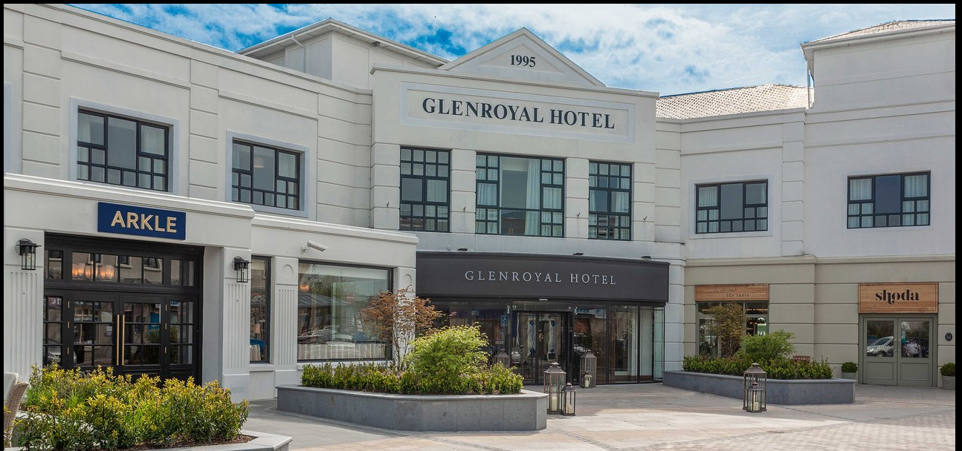

Gender Pay Gap Report

December 2025

Glenroyal Hotel & Leisure Club

Introduction from Paul Joy, General Manager

People are at the heart of what we do. We believe that a fair, open and accommodating workplace generates an atmosphere which enables all employees to reach their full potential and contribute to a high level of customer satisfaction. In order to provide the best service possible for our guests, it is essential that we continue to nurture an inclusive culture that attracts and retains a diverse workforce.

Our Gender Pay Gap Report for 2025 has highlighted some areas that we are very proud of, as well as areas that we know we need to improve on. Our Senior Leadership Team is 50% female, which compares favourably to other companies in Ireland. This positive gender balance is visible at almost all levels in our Hotel, however we do see that women are underrepresented in our Upper Band, and this will be one area of focus for 2026.

While we regularly ensure that equal pay is provided for equal work, we also have to account for the fact that hotels constitute a diverse range of roles and responsibilities, that require very different levels of education and training. And although we see a Gender Pay Gap of 14.51%, the median gender pay gap was less than 1% which highlights a more balanced gender pay gap across entry level and junior roles, and demonstrates our commitment to equal pay for similar roles.

Overall, we can see that we have more work to do. For 2025 we will undertake a number of measures to reduce our Gender Pay Gap, including consultation with our female colleagues in order to identify any potential barriers for advancement. Communication is a vital part of our Diversity, Equality & Inclusion Policy and will be essential to bridging any gap.

All of our team members are vital to our success, and we believe it is important for everyone to be rewarded fairly for their work and commitment. We look forward to the coming year and to achieving all that we can.

Paul Joy General Manager of Glenroyal Hotel & Leisure Club

What is the Gender Pay Gap?
The gender pay gap is the difference in the average hourly salary of women and men across an organisation. Under The Gender Pay Gap Information Act 2021 we are now obliged to report on our hourly gender pay gap across a range of metrics.

- Mean Gender Pay Gap for the entire company: 14.51%
How is this calculated?
- A snapshot of 28th June 2025 was chosen
- The period of reporting is the previous 12 months, 29th June 2024 – 28th June 2025
- Employees ordinary pay, plus any bonus, LTIP or Benefit in Kind paid in that period, is divided by the total number of hours worked to calculate the average hourly wage
- Subtract the average hourly wage of all the females from the average hourly wage of all the males
- Divide the result by the average hourly wage for men
- Multiply the result by 100

Median Gender Pay Gap | 0.71 %
Mean Gender Pay Gap - Temporary and Part Time Employees | 0.25%
Median Gender Pay Gap - Temporary and Part Time Employees | -0.56%
Mean Bonus Gender Pay Gap | -15.87%
Median Bonus Gender Pay Gap | -71.43%
Percentage of Female Employees receiving a bonus | 5%
Percentage of Male Employees receiving a bonus | 10 %
Percentage of Female Employees receiving Benefit in Kind | 4%
Percentage of Male Employees receiving Benefit in Kind | 5%
The percentage of male and female employees in each of the four pay band quartiles | Page 4

Glenroyal Hotel & Leisure Club Structure

Glenroyal Hotel is a four-star hotel located in the heart of Maynooth. On the snapshot date we had 195 employees. Our hotel structure is led by the General Manager, and a team of 10 Senior Managers. Each department has different levels of roles, all reporting into a Head of Department.

How are we addressing the Gender Pay Gap?
This is our second year to report on the Gender Pay Gap, and the results reflect the work we need to do. Our main objective for 2026 is to consult widely with female employees of all levels in the business, to identify what the main barriers are and what actions we need to take to help alleviate those barriers.

We are fully aware that a 0% gap is not something that will be achievable in the short term, however we can begin laying the foundations for this to happen in the future.

- Identify and begin to implement actions from the work on identifying barriers for female career progression
- Introduce targeted development, mentoring and succession planning programmes to support more women progressing into the upper quartile
- Examine succession planning and identify how we can develop a gender balanced pipeline of future talent
- Standardise and clearly document bonus criteria and decision-making processes to ensure transparency and consistency across genders
- Aim to role model female leaders in the hotel

Proportion of Male and Female employees in each pay quartile | Female | Male
Lower | 64% | 36%
Lower Middle | 49% | 51%
Upper Middle | 71% | 29%
Upper | 37% | 63%

